|  |  |
| --- | --- |
|  | **Example:**  **Formula for Arc Length** |

**Objectives:** (1) To explore the relation between the arc length and the angle at centre of a sector.

(2) To find the formula for the arc length of a sector

**Key Stage:** 3

**Learning Unit:** Arc lengths and areas of sectors

**Materials Required:** Dynamic Geometry software such as *Geometer’s Sketchpad* (later referred as *Sketchpad*) and the file arc01.gsp

**Prerequisite Knowledge:** Basic concepts about angles and ratio

**Description of the Activity:**

1. The teacher explains the terms “arc”, “arc length” and “angle at centre” to the class.
2. The teacher distributes the worksheet to students and briefly explains the activity.
3. 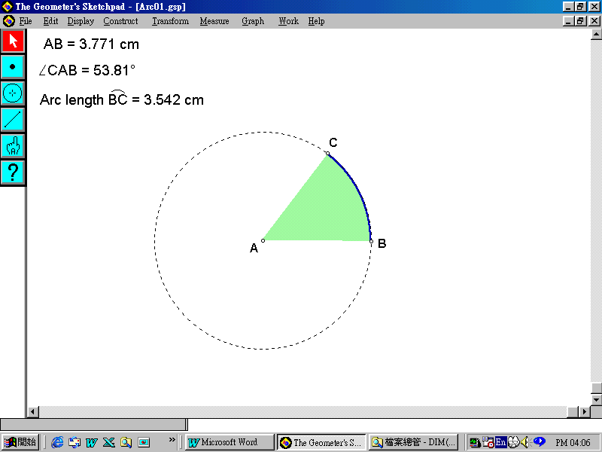Students are asked to complete the worksheet by using the *Sketchpad* file arc01.gsp (see figure below).

In completing the tasks on the worksheet, students need to make a conjecture on the relation between the arc length and the angle at centre of a sector.

1. After completing the worksheet, the teacher invites some students to present their conjectures to the class.
2. The teacher guides students to conclude that
3. the arc length and the corresponding angle at centre are always in a constant ratio; and
4. point (a) is true for circles of different radii.
5. The teacher asks students to justify their conjectures.
6. The teacher makes comments on students’ presentations, and, if necessary, facilitates them with some special cases to formulate their justifications.
7. The teacher guides students to deduce the formula for the arc length of a sector.

**Worksheet: To investigate the relation between the arc length and the angle at centre of a sector**

**Instructions:**

1. Open the *Sketchpad* file arc01.gsp.
2. Drag the point *B* to obtain a circle of appropriate size if necessary.
3. Measure and fix the radius of the circle.  
   Drag the point *C* on the circle to obtain different arc lengths and different angles at centre. Record 5 different sets of arc lengths and their corresponding angles at centre in Table 1.  
     
   The radius of the circle = _____________ cm.

|  |  |  |
| --- | --- | --- |
| Data | Arc length (cm) | Corresponding angle at centre |
| 1 |  |  |
| 2 |  |  |
| 3 |  |  |
| 4 |  |  |
| 5 |  |  |

Table 1

1. Is there any relation between the arc length and its corresponding angle at centre? Write down your conjecture below.

__________________________________________________________________________________________________________________________________

1. Drag the point *B* on the circle to get a circle of a different radius. Repeat point 3 above and record a new set of data in Table 2.  
     
   The radius of the circle = _____________ cm.

|  |  |  |
| --- | --- | --- |
| Data | Arc length (cm) | Corresponding angle at centre |
| 1 |  |  |
| 2 |  |  |
| 3 |  |  |
| 4 |  |  |
| 5 |  |  |

Table 2

1. Does your conjecture from question 4 still hold? _________
2. Discuss with your classmates why your conjecture still holds.

**Notes for Teachers:**

1. The teacher should upload the file arc01.gsp onto the school’s e-platform.
2. It should be aware that the ratio between the arc length and the angle at centre might not be a constant due to the rounding error.
3. 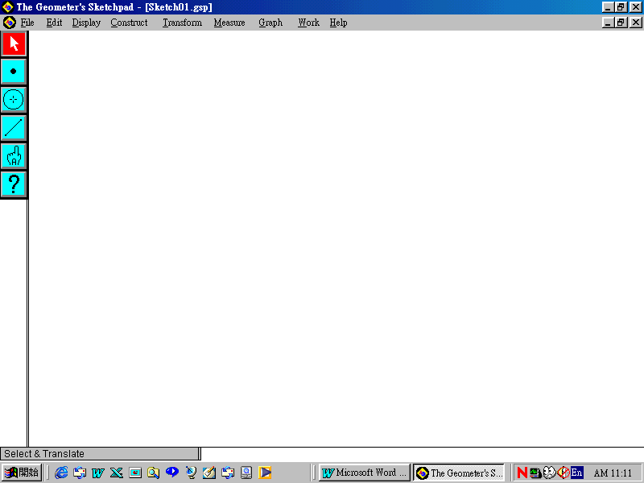It should be noted that the some of the terms used in the *Sketchpad* file may be different from the usual terminology used by students when they construct the *Sketchpad* file by themselves. For example, they have to use “Arc angle ” to measure ∠*BAC* and use “Arc length ” to measure the arc length . Afterwards, they have to rename the angle by highlighting “Arc angle ” and choose the **Text Tool** icon . Hold down to select the **Number Lock** and double click the “Arc angle ” until an **Edit Math-Formatted Text** dialogue box appears. Type “{!:*A*}*CAB*” in the **Math Format String** and press **Apply** to change the name “Arc angle ” to “∠*CAB*”. Repeat the above process and enter “Arc length {*A:BC*}” to change the name “Arc length ” to “Arc length ”.
4. The teacher can use sectors of the same radius with angles at centre equal to 10° and 20° to explain the fact that the arc length is directly proportional to the angle at centre.
5. For less able students, Table 1 can be modified as follows:

|  |  |  |  |
| --- | --- | --- | --- |
| Data | Arc length（*s* cm） | Corresponding angle at centre（θ°） |  |
| 1 |  |  |  |
| 2 |  |  |  |
| 3 |  |  |  |
| 4 |  |  |  |
| 5 |  |  |  |